**Population demographics and dynamics of coconut crabs (*Birgus latro*) on Aldabra Atoll, Seychelles**

Jennifer Appoo1*, Fernando Cagua2*, Janske van de Crommenacker3 *et al.,*

1Seychelles Islands Foundation, P.O. Box 853, Victoria, Mahé, Seychelles;

*These authors contributed equally to the work

Correspondence: J. Appoo; email: [aasc@sif.sc](mailto:aasc@sif.sc)

**Abstract**

Island species are highly vulnerable to disturbances linked to human interference and habitat loss. Increased knowledge about the remaining healthy populations is important for their conservation. The coconut crab, *Birgus latro* (Linnaeus, 1767)*,* is one such species, with population declines documented across its range. Aldabra Atoll hosts a significant and unexploited *B. latro* population. This study investigated the spatial and temporal dynamics of *B. latro* on Aldabra over a period of nine years. *B. latro* individuals were assessed; the mean density was 35.4 ± 1.69 ind./ha and has remained stable over the study period. The population exhibited high spatial and temporal variability over density, size and sex. The *B. latro* observed population on Aldabra is heavily skewed towards males (sex ratio 3:1 male to female) and size is sexually dimorphic with males attaining larger sizes (mean thoracic length 40.9mm) than females (mean thoracic length 30.6mm). For such a dynamic species, long terms studies are necessary to provide accurate information and develop conservation measures. Aldabra represents a refuge for *B. latro* and holds the potential to repopulate other protected areas in the Western Indian Ocean.

**Key words**: crab density, moulting, reproductive season, sex ratio, spatial variability, temporal dynamics.

**Introduction**

Present extinction rates of species globally are exceptionally high, estimated to be around 100 extinctions per million species per year (Pimm *et al.,* 2014). This is 1,000 times higher than the natural background extinction rate (de Vos *et al.,* 2014). Around 10,673 species are classified as data deficient on the IUCN Red list, meaning that their threat status cannot be assessed due to uncertainties in species taxonomy, distribution, population status or unknown threats (Veron *et al.,* 2016). These uncertainties impact the likelihood of active conservation measures being adopted. Unless directly targeted for monitoring, species classified as data deficient are likely to go extinct without notice (Bland *et al.,* 2014). Taking into account information on data deficient species may therefore help fill data gaps in biodiversity indicators, as well as conserve poorly known biodiversity (Bland *et al.,* 2014). Likewise, the conservation attention paid to invertebrates lags far behind that of vertebrates (mammals, birds, reptiles, amphibians and fish) (Collen *et al.,* 2012). It is crucial to understand the conservation status and trends of invertebrates, since it is these often cryptic and overlooked species that are essential for the functioning of ecosystems (Baillie *et al.,* 2010).

The largest land arthropod, the coconut crab (*Birgus latro),* is classed as data deficient (Eldredge, 1996) due to limited information on the status of the different populations (Drew *et al.,* 2010). Although *B. latro* has a broad geographical range in the tropical Indo-Pacific region, the size and distribution of the populations have been significantly reduced in areas where the species were sympatric with humans (Schiller, 1992). This decline is mostly attributed to loss of habitat and unmanaged harvesting for human consumption (Drew *et al.,* 2010). Despite being present in large quantities all across the Indo-Pacific (Drew *et al.*, 2010), in the Indian Ocean, the distribution is now largely confined to three populations centred on Aldabra Atoll, Chagos Archipelago and Christmas Island (Lavery *et al.,* 1996). *B. latro* is locally extinct in Mauritius (Eldredge, 1996) and is believed to be no longer present on Mayotte and the Comoros Islands (Poupin *et al.,* 2013), and has only been occasionally recorded with low incidence in Aride, Cousine and some of the outer Seychelles islands (Poupin *et al.,* 2013). Despite *B. latro*’s relative rareness and documented threats, information on the species life-history, behaviour, and ecological requirements is insufficient (Drew *et al.,* 2010), making it difficult to assess status and design potential conservation measures.

Previous studies have established the importance of the species on island ecosystems. *B. latro* are scavengers of major importance, they remove rotting material and so reduce the number of carrion breeding flies, help to decompose leaf litter, contribute greatly to seed dispersal, providing a food source for birds in the juvenile stage and in turn influence the populations of crab species upon which the birds prey (Alexander 1976). In particular for Aldabra, *B. latro* scavenges the remains of dead tortoises, tortoise and marine turtle eggs and hatchlings (Haigh, 1984). Furthermore, *B. latro* also contribute to soil aeration and erosion through their burrowing activity (Alexander, 1976).

Here, we investigate the demographics and dynamics of *B. latro* on Aldabra Atoll, where the species has benefited from complete protection since it's designation as a special reserve in 1981 and UNESCO World Heritage Site in 1982. *B. latro* is widely distributed throughout the atoll, inhabiting rock crevices, deep potholes, vegetation and sandy areas (Grubb, 1971). In spite of being one of the last remaining viable populations in the Indian Ocean, the status and ecological characteristics of Aldabra’s *B. latro* population has never been defined.

This paper presents the results of a nine-year study where counts and biometric data were collected on *B. latro* individuals at regular intervals. Due to its isolation and protection, we hypothesise that Aldabra hosts a significant *B. latro* population with potential to be a source population for translocations to other protected areas within its known historic range. The overall goal is to define a baseline of the population structure and its spatial and temporal variability and provide ecological parameters that contribute towards appropriate monitoring and conservation strategies in Aldabra and elsewhere. We hope to give *B. latro* the conservation leverage it deserves.

**Materials and methods**

Study site

Aldabra Atoll (9°25′0″ S, 46°24′59″ E) lies in the Western Indian Ocean and forms part of the Seychelles archipelago. It is located approximately 1100 km south west of Mahé, the principal island of the Seychelles and 420km from Madagascar (Fig. 1). Aldabra is the second largest raised coral atoll, ca. 34 km long and 14 km wide, and it is composed of a characteristic and irregular coral limestone formation termed as ‘champignon’. The terrestrial environment is dominated by a dense scrub of varying height, either continuous or in a mosaic with open rocky ground (Hnatiuk & Merton, 1979). Aldabra’s climate is determined by two distinct seasons: the wet season of the northwest monsoon from November to April (Stoddart & Mole, 1977), while between May to October there is lower rainfall resulting from the southeast monsoon winds.

[Figure 1]

Sampling

The distribution of *B. latro* is thought to be structured by distance from the coastline (Schiller, 1992). Therefore *B. latro* population surveys were conducted on two transects established at different distances from the shore (Fig. 1). A predominantly coastal transect was 1.4 km long, composed of 27 lineal sections of 50 m and separated from the shore by distances ranging between 1 and 26 m. A predominantly inland transect was 1.8 km long, composed of 39 lineal sections of 50 m with distances from the shore ranging between 38 and 177m. Both transects were surveyed simultaneously after sunset, roughly every two weeks between January 2007 and May 2016.

All B. latro individuals encountered within five meters on either side of the mid transect line were recorded. For each individual encounter, the following parameters were recorded.

1. Distance to the mid transect line, estimated to the nearest meter.
2. Sex. The sex of crabs was identified; female crabs possess three large, feathery pleopods on the ventral surface of the abdomen which are used to support their egg-masses (Fletcher, 1993). Male crabs do not have the pleopods. When a female was identified, it was noted whether it was carrying eggs or not.
3. Thoracic length. Pistorius (2006) established a highly significant relationship between weight and thoracic length for the B. latro population on Aldabra, corresponding to findings in other studies (Amesbury, 1980; Anagnostou & Shubart, 2014; Helagi et al., 2015). Therefore, the thoracic length, the linear distance between anterior and posterior borders of the thoracic groove (Helfman, 1973), of each individual encounter was measured using vernier callipers;
4. Moult. several studies (Amesbury, 1980; Fletcher et al., 1990 and Held, 1963 cited by Drew et al., 2010) noted a distinct expansion of the abdomen on B. latro prior to moulting. Pleonal expansion has also been linked to the reproductive condition of females, as it can be indicative of gonad development (Fletcher et al., 1991; Sato & Yoseda, 2009). Therefore, during each encounter, the degree of pleonal expansion using a four-level categorical scale was recorded. In this scale, 1 was assigned to individuals in which all tergal plates are touching each other or if there is only a small gap between the most posterior tergal plate (first plate) and the next (second plate). An index of 2 was assigned to those in which the pleon was slightly swollen and the fleshy abdomen is visible between the first and second plates, and somewhat visible between the second and third plate. An index of 3 was assigned if the pleon was swollen and the fleshy abdomen is clearly present between the first, second and third plates, and somewhat visible between the third and the fourth plate. Finally, an index of 4 indicates a strongly swollen pleon and the fleshy abdomen is visible between all tergal plates.

Habitat classification

Habitat along the transects was representative of the dominant landscape in Aldabra. To control for potential habitat effects, composition was determined using high resolution satellite imagery (Walton, 2015) and classified into eight different habitat types. In each transect section the percentage of area occupied by the different habitat types that could affect *B. latro* detectability and/or abundance was calculated. In decreasing order of area occupied these habitats were: open mixed scrub, exposed surface, standard mixed scrub, grasses, mangrove, sand, dense *Pemphis acidula* bush, and champignon.

**Data analysis**

Density and abundance

The density of *B. latro* during each survey was estimated using the hierarchical distance sampling model of Royle *et al.,* (2004) implemented in the R package unmarked (Fiske & Chandler, 2011). The numbers of individuals within the five distance categories 0−1, 1−2, 2−3, 3−4, 4−5m from the mid-transect line were used to estimate the overall density and evaluated the impact that habitat composition had in both the detectability and abundance of *B. latro*.

To maximise differentiation between transect sites and reduce the dimensionality of the data, habitat composition percentages were transformed using a principal component analysis. Finally, the two components were included, explaining the largest proportion of the variance as covariates in the distance sampling model. Due to the large number of surveys, a fixed effects meta-analysis approach was used to ascertain the significance of the covariates. A covariate was determined to significantly affect detectability if its effect was consistent over different surveys, and to significantly affect abundance if its effect was either consistent over surveys or variable but according to the seasons. In each survey, the Akaike Information Criterion (AIC) was used to determine whether the detection process was better approximated by a half-normal, a negative exponential, a hazard-rate, or a uniform distribution function.

Next, a generalised additive model (GAM) was used to determine whether *B. latro* densities varied significantly (i) over the years, (ii) over the yearly cycle, and (iii) over the lunar cycle. Models were fitted using the R package mgcv (Wood, 2006a), and the model parsimony was assessed by comparing their AIC values. The phase of the moon during the survey was back calculated using the R package oce (Kelley & Richards, 2015) and was defined as a continuous variable from zero to one with both extremes corresponding to new moon, 1/4 for first quarter, 1/2 for full moon, and 3/4 for last quarter (Meeus, 1982).

To analyse abundance patterns at a finer spatial and temporal scale, a set of GAM was used to quantify the relative effect of the aforementioned variables on the counts of both male and female individuals. This was possible because initial analysis indicated that crab detectability did not change over time and was not influenced by habitat composition (see Results) and consequently direct counts provide an accurate index of crab abundance. As it is plausible that environmental factors interact with habitat requirements, the tensor product interaction between day of the year and distance from shore was included in the model.

Sex ratio and sizes

Sex ratios were directly calculated from the individual counts. In addition, for sake of the potential reference for reproduction, the sex ratio that would be observed if only sexually mature individuals were included was calculated. Full sexual maturity was assumed based on individuals with a thoracic length of and longer than 28mm (Fletcher *et al.,* 1990; Sato & Yoseda, 2008; Drew *et al.,* 2010). All studied island populations of *B. latro* reveals males being consistently larger than females (Drew *et al.,* 2010). Therefore thoracic length was also used to determine whether the Aldabra population also exhibits size sexual dimorphism. The difference was evaluated by visually inspecting the size distribution for both sexes and a t-test on the length measurements. A set of GAMs were used to infer the effects that time of the year, distance from shore, and phase of the moon may have on the sex ratio and sizes of individuals encountered, with competing models compared using their AIC.

Moulting and reproduction

To understand whether there is evidence of synchronous seasonal moulting, and to provide insight into the onset of reproductive season, two GAMs were constructed, one for each sex, in which the response was the index of pleonal expansion (treated as a numeric variable) and the predictor was the time of the year. To determine the reproductive season of *B. latro* on Aldabra a GAM with a binomial error distribution was constructed with the response variable whether a female was seen carrying eggs during a survey transect or not, with time of the year and phase of the moon as response variables.

**Results**

Density and abundance

Overall, 281 surveys were performed over the study period which led to a total of 8145 individual encounters. The two principal components of the habitat composition explained 81% of the variance found among transect sections (Supplementary information Fig. 1). The first component was strongly correlated with an increase on the area covered by open mixed scrub, but mainly with a decrease on percentage of exposed surface. The second component was largely correlated with an increase of grass and with a decrease of standard mixed scrub. These habitat differences, however, did not significantly affect the detectability or the abundances of *B. latro* (Supplementary Information Fig. 2 and 3). Overall, based on AIC values, the most parsimonious models were those fitting a negative exponential function to the detection process.

*B. latro* density in the study area varied between 3.2 and 189.4 individuals per hectare, with an overall average density of 35.4 ± 1.69 ind./ha. The overall density shows small variations over the years, but no long term trend is observable (Fig. 2A). Similarly, there was no significant variation on density with moon cycle (p=0.916). Contrastingly, there were important seasonal changes on abundance, being above average between February and June, with a clear peak in April, and below average for the rest of the year (Fig. 2B).

The number of *B. latro* males and females encountered is strongly affected by the time of the year and the distance from shore. In general, male counts in each transect section were largest during the first half of the year. Within that period, between March and April, males concentrate away from shore (Fig. 3A). During the same period, when inshore counts are high for males, female counts are higher closer to shore. In contrast, during the second half of the year when male counts are the lowest, female counts are at the highest both in coastal and inshore sections, particularly between October and November (Fig. 3A).

Although moon phase did not affect the overall *B. latro* densities, it had distinct and complementary effects on males and females (Fig. 4A). While female counts are the largest during periods of full moon, males are encountered in higher densities during new moon when the illuminated fraction of the moon is at its minimum.

[Figure 2, 3, 4]

Sex ratio and sizes

The overall *B. latro* ratio males: females was approximately 3:1 (76% male), which increases to approximately 4:1 (82% male) if only sexually mature individuals are included. As inferred by the count models, this ratio however, shows significant temporal and spatial variation, ranging between 57% of individuals encountered being male during November in areas close to shore and 86% during March in areas far from shore.

In addition to female crabs being recognized by three additional large, feathery pleopods on the ventral surface of their abdomen, a marked size sexual dimorphism was observed (Fig. 5). Male thoracic length, ranged from 9 to 78mm (mean 40.9 mm, median 48.8 mm), while female ranged from 6 to 76mm (mean 30.6 mm, median 48.9 mm. Although the distributions of the two groups did not differ significantly (Mann–Whitney, n1 = 6182, n2 = 1994, P = 0.725 two-tailed), large males were significantly larger than female counterparts (Mann–Whitney of upper decile, n1 = 666, n2 = 197, P < 0.001). The mean size, of both male and female individuals encountered, showed two distinct peaks during the year, one between October and December, and another more pronounced between March and May (Fig. 3B). In addition, the mean sizes were found to be affected by the distance to shore. In general, females encountered close to shore were generally larger than those encountered inland. On the other hand, males found away from the coast were substantially larger than those encountered close to shore. However, this difference on male size between coastal and inshore habitats becomes inconspicuous in December and January and from June to August (Fig. 3B). Furthermore, the size of males encountered close to new moon was significantly larger than that of males encountered close to full moon. In contrast, the size of encountered females showed no variation over the moon cycle (Fig. 4B).

[Figure 5]

Moulting and reproduction

Males over 30mm were found to exhibit a yearly cycle regarding the size of their pleon, with a clear peak in April and May (Fig.6). In contrast, females encountered in November have the largest pleon. In addition, females show an additional less conspicuous peak of pleon expansion between May and July (Fig. 6).

Throughout the monitoring period, few *B. latro* females (14 out of 2071 individuals in 12 out of 438 transect surveys) were ovigerous. Nevertheless, these observations consistently pointed out to a reproductive season between December and March with an increased probability to encounter females carrying eggs just before new moon (Fig. 7).

[Figure 6, 7]

**Discussion**

The density of *B. latro* has been stable in the survey location on Aldabra over the nine years of the study period. We found a substantial spatial and temporal heterogeneity on observed densities which suggests a highly dynamic behaviours—likely in response to climate and resource competition. Despite being a dry coral atoll with relatively low primary productivity, Aldabra might potentially have one of the most significant *B. latro* populations worldwide likely as a consequence of not being exploited. The only other two unexploited populations of *B. latro* have densities estimated at 147 crabs/ha (Enewetok, Marshall Islands, 5.85 km2; Helfman, 1973) and 190 crabs/ha (Taiaro, French Polynesia, 12 km2; Chauvet & Kadiri-Jan, 1999). However, these islands are relatively small when compared to Aldabra Atoll (35 crabs/ha; 155km2). In Christmas Island (135 km2), where the *B. latro* population experiences limited exploitation has densities estimated to be between 4−47 crabs/ha; however Drew & Hansson (2014) reported significant decline. It is important to mention that the survey methodologies used for these above-mentioned assessments differ, and tended to be focused on areas known to be preferred by *B. latro*.

As observed in all other studied populations, *B. latro* on Aldabra is sexually dimorphic, with males attaining larger sizes than females. Interestingly, the mean thoracic length of *B. latro* recorded on Aldabra is considerably smaller than all other studied populations (see Drew *et al.,* 2010). Resource limitation might be the reason behind this difference. *B. latro* compete intensively hermit crabs of the genus *Coenobita*, which are abundant on Aldabra (Grubb, 1971). In areas with high abundance of *Coenobita*, the amount of scavengeable material available to *B. latro* may be limited, as well as the availability of gastropod shells for the glaucothoe stage (Amesbury, 1980). The interspecific competition might be compounded by the drought frequency on Aldabra, which is reported to have increased from two to six months per year between 1970 and 2013 (Haverkamp *et al.,* 2017). *B. latro* is suggested to exhibit a decrease in the frequency of their foraging activity during the dry season compared to the wet season (Fletcher, 1993), thereby resulting in a slower growing population on Aldabra.

At the spatial scale of this study, sex ratio appears to be biased towards males, most likely as a result of the cryptic nature of the species and the sampling design. Transect studies typically report male bias ratios compared to grid sampling and are sensitive to variations in habitat use between sexes (Drew *et al.,* 2012). Female crabs have been shown to have affinity to dense vegetation and are therefore less likely to be encountered on transects along existing paths (Drew *et al.,* 2012). In addition, James (2008) suggested a more sedentary behaviour of female *B. latro* outside of the breeding season, suggesting that the males are wider ranging, increasing their chances of being encountered in surveys along pathways.

The high spatial and temporal variability of *B. latro* density, size and sex is most likely linked with a complex life cycle associated with reproductive migrations, moulting requirements, availability of resources, and behavioral variations associated with environmental conditions at a site (Drew & Hansson, 2014). From February to May, the overall number of crabs observed is higher than average. This is largely due to an increase in the number of males. During this time, large dominant males favour areas further from shore, presumably richer in resources, while females and smaller males are mostly encountered in near-shore habitats. Drew & Hansson (2014) noted that large males often actively exclude females and potentially smaller males from desirable feeding locations. Afterwards, roughly from June to December, the overall number of crabs is lower than average. Again, largely due to a decrease on the number of males, particularly of large ones, which are potentially undergoing moulting during the drier months of the year (Fletcher *et al.,* 1991). *B. latro* undergoes moulting in shallow burrows to minimize their vulnerability to predation and desiccation during the moulting process (Drew *et al.,* 2010). Contrastingly , female counts increase on the second half of the year both in the coastal and inshore areas, likely opportunistically exploiting the available resources left by dominant males (Drew & Hansson, 2014). Female densities peak between September to December close to shore which coincides with a period in which males of sexually active sizes are commonly encountered. This suggest a breeding migration of female *B. latro* which involves females moving to the coast to release larvae into the ocean (Schiller *et al.,* 1991). The few studies detailing mating behavior in *B. latro,* indicate that copulation is brief and not preceded by elaborate courtship (Brown & Fielder, 1991).

Based on encounters with ovigerous females, the reproductive season on Aldabra occurs with most likelihood between December and March, during the rainy season. This also corresponds with the period of highest peak of female pleonal expansion in November to December, which is believed to be related to gonad development (Fletcher *et al.,* 1991; Sato & Yoseda, 2009). This period coincides with the reproductive seasons observed in other *B. latro* populations in the southern hemisphere (Drew *et al.,* 2010). Moreover, signs of synchrony with the moon cycle were found as ovigerous females were mostly encountered during surveys performed close to new moon. This synchrony is likely related to the timing of spawning or egg extrusion (Sato & Yoseda, 2009). The timing between mating and egg extrusion is unknown. As female individuals don't possess a seminal receptacle, it is believed that egg extrusion occurs shortly after mating (Sato & Yoseda 2009; Drew *et al.,* 2010).

Altogether, our results suggest that the *B. latro* population in Aldabra might be close to carrying capacity. Although some additional research regarding life history and ecological requirements are required, Aldabra appears to be a potentially viable source of individuals for eventual translocations. We hope similar long term studies under natural conditions are prioritised for other *B. latro* populations, especially in locations where the species is exploited. Although the highly cryptic nature of the species and the seasonal variability might complicate monitoring, more studies are essential to revise of the IUCN redlist threat status of *B. latro* and leverage conservation efforts for this remarkable species

**Conclusion**

This study uses one of the longest continuously recorded data set on *B. latro* populations and provides additional insight into the ecology of this species. *B. latro* on Aldabra is highly dynamic due mainly to their life history traits and resource availability. With a significant, stable and unexploited *B. latro* population, Aldabra Atoll represents a refuge for this species recorded to be on decline elsewhere throughout their range and potentially a crucial reservoir for repopulating other suitable islands in the Western Indian Ocean (Poupin *et al.,* 2013). Aldabra as a research base is in a privileged position to unravel long held questions on *B. latro*. Its strict protection from human disturbance provides the opportunity to investigate the potential for this species to persist in the face of global climatic changes and provide important lessons for other managed and unmanaged populations elsewhere.

**Acknowledgements**

**References**

Alexander, H.G.L. 1976. An ecological study of the terrestrial decapod Crustacea of Aldabra. Ph.D. thesis, University of London.

Amesbury, S.S. 1980. Biological Studies on the Coconut Crab (*Birgus latro*) in the Mariana Islands. Agriculture Experiment Station, College of Agriculture and Life Sciences, University of Guam, Technical report no. 17.

Anagnostou, C. & Schubart, C. 2014. Morphometric characterisation of a population of adult coconut crabs *Birgus latro* (Decapoda: Anomura: Coenobitidae) from Christmas Island in the Indian Ocean. *Raffles bulletin of zoology.* Supplement No. **30**: 136–149.

Baillie, J.E.M., Griffiths, J., Turvey, S.T., Loh, J. & Collen, B. 2010. Invertebrata: Are vertebrates representative of animal biodiversity as a whole? In: *Evolution Lost: Status and Trends of the World’s Vertebrates* (M. Samways & M. Böhm, eds.) Zoological Society of London, United Kingdom. pp. 55–61.

Bland, L.M., Collen, B., Orme, C.D.L. & Bielby, J. 2014. Predicting the conservation status of data-deficient species. *Conservation Biology*, Volume **00**, No. 0: 1–10. doi: 0.1111/cobi.12372

Brown, I.W. & Fielder, D.R. 1991. Project overview and literature survey. In: *The Coconut Crab: Aspects of biology and ecology of Birgus latro in the Republic of Vanuatu*. (I.W. Brown & D.R Fielder, eds.) Australian Centre for International Agricultural Research, Canberra, pp. 1–11.

Chauvet, C. & Kadiri-Jan, T. 1999. Assessment of an unexploited population of coconut crabs, *Birgus latro* (Linne, 1767) on Taiaro atoll (Tuamotu Archipelago, French Polynesia). *Coral Reefs* (1999) **18**: 297–299.

Collen, B., Böhm, M., Kemp, R. & Baillie, J.E.M. 2012. *Spineless: status and trends of the world’s invertebrates*. Zoological Society of London, United Kingdom. ISBN 978-0-900881-70-1 (online version).

de Vos, J.M., Joppa, L.N., Gittleman, J.L., Stephens, P.R. & Pimm, S.L. 2014. Estimating the normal background rate of species extinction. *Conservation Biology*, Volume **00**, No. 0: 1–10. DOI: 10.1111/cobi.12380.

Drew, M.M. & Hansson, B.S. 2014. The population structure of *Birgus latro* (Crustacea: Decapoda: Anomura: Coenobitidae) on Christmas Island with incidental notes on behaviour. *Raffles bulletin of zoology.* Supplement No. **30**: 150–161.

Drew, M.M., Hartnoll, R.G. & Hansson, B.S. 2012. An improved mark-recapture method using passive integrated transponder (PIT) tags in *Birgus latro* (Linnaeus, 1767) (Decapoda, Anomura). *Crustaceana* **85** (1): 89–102. DOI: 10.1163/156854012X623656

Drew, M.M., Harzsch S., Stensmyr, M., Erland, S. & Hansson, B.S. 2010. A review of the biology and ecology of the Robber Crab, *Birgus latro* (Linnaeus, 1767) (Anomura: Coenobitidae). *Zoologischer Anzeiger -* *A Journal of Comparative Zoology* **249** (1). Elsevier: 45–67. doi:[10.1016/j.jcz.2010.03.001](https://doi.org/10.1016/j.jcz.2010.03.001)

Eldredge, L.G. 1996. *Birgus latro*. The IUCN Red List of Threatened Species 1996:e.T2811A9484078. <http://dx.doi.org/10.2305/IUCN.UK.1996.RLTS.T2811A9484078.en>

Fiske, I. & Chandler. R. 2011. ‘unmarked’: an R package for Fitting Hierarchichal Models of Wildlife Occurrence and Abundance. *Journal of Statistical Software* **43** (10): 1–23. doi:[10.18637/jss.v043.i10](https://doi.org/10.18637/jss.v043.i10)

Fletcher, W.J., Brown, I.W. & Fielder, D.R. 1990. Growth of the coconut crab *Birgus latro* in Vanuatu. *Journal of Experimental Marine Biology and Ecology* **141**: 63–78.

Fletcher, W.J., Brown, I.W., Fielder, D.R. & Obed, A. 1991. Moulting and growth characteristics. In: *The Coconut Crab: Aspects of biology and ecology of Birgus latro in the Republic of Vanuatu* (I.W. Brown & D.R Fielder, eds.). Australian Centre for International Agricultural Research, Canberra, pp. 35–60.

Fletcher, W.J., 1993. Coconut crabs. In: *Nearshore marine resources of the south Pacific. Institute of Pacific Studies* (A. Wright & L. Hill, eds.). University of the South Pacific. FFA and ICOD, pp. 643–681. ISBN 982-02-0082-2

Grubb, P. 1971. Ecology of terrestrial decapod crustaceans on Aldabra. *Philosophical transactions of the Royal Society of London*. *B* (1971) **260**: 411–416. doi: 10.1098/rstb.1971.0020

Haig, J. 1984. Land and freshwater crabs of the Seychelles and neighbouring islands. In: *Biogeography and ecology of the Seychelles Islands* (D.R. Stoddart, eds.). Dr W. Junk Publishers, The Hague, Boston, Lancaster. ISBN 90-6193-107-X

Harper, G.A., van Dinther, M., Russell, J.C. & Bunbury, N. 2015. The response of black rats (*Rattus rattus*) to evergreen and seasonally arid habitats: Informing eradication planning on a tropical island. *Biological Conservation* **185** (2015): 66–74. http://dx.doi.org/10.1016/j.biocon.2014.11.044

Haverkamp, P.J., Shekeine, J., de Jong, R., Schaepman, M., Turnbull, L.A., Baxter, R., Hansen, D., Bunbury, N., Fleischer-Dogley, F. & Schaepman-Strub, G. 2017. Giant tortoise habitats under increasing drought conditions on Aldabra Atoll- Ecological indicators to monitor rainfall anomalies and related vegetation activity. *Ecological Indicators* **80** (2017): 354–362. http://dx.doi.org/10.1016/j.ecolind.2017.05.029

Helagi, N., Tafatu, J., Bertram, I., Moore, B., Linawak, M. & Pakoa, K. 2015. *Status of the coconut crab Birgus latro in Niue*. Niue Department of Agriculture, Forestry and Fisheries. Pacific Community. Vanuatu Fisheries Department. ISBN: 978-982-00-0949-3

Helfman, G. S. 1973. Ecology and behavior of the coconut crab, *Birgus latro* (L.). Master’s Thesis, Univ. of Hawaii. 158 p.

Hnatiuk, R. & Merton, L. 1979. A Perspective of the Vegetation of Aldabra. *Philosophical transactions of the Royal Society of London B: Biological Sciences,* **286** (1011): 79–84. http://dx.doi.org/10.1098/rstb.1979.0017

James, D.J. 2008. Christmas Island Biodiversity Monitoring Program: December 2003 to April 2007. Report to the Department of Finance and Deregulation from the Director of National Parks.

Kadiri-Jan, T. 1995. Biology and population dynamics of the coconut crab (*Birgus latro*) in Loyalty Island, New Caledonia. Universite Francaise du Pacifique, New Caledonia.

Kelley, D. & Richards, D. 2015. oce: Analysis of Oceanographic Data. <http://cran.r-project.org/package=oce>.sato

Lavery, S., Moritz, C. & Fielder, D.R., 1996. Indo-Pacific population structure and evolutionary history of the coconut crab *Birgus latro*. *Molecular Ecology* (1996) **5**: 557–570.

Linnaeus, C. 1767. Classis V. Insecta. In: *Systema Naturae per Regna tria Naturae*. Vol. **1** (2): 533-1327 [1049].

Meeus, J. 1982. *Astronomical formulae for calculators*. 2nd ed. Richmond: Willmann-Bell.

Pimm, S.L., Jenkins, C.N., Abell, R., Brooks, T.M., Gittleman, J.L., Joppa, L.N., Raven, P.H., Roberts, C.M. & Sexton, J.O. 2014. The biodiversity of species and their rates of extinction, distribution, and protection. *Science* **344**, 1246752 (2014). DOI: 10.1126/ science.1246752.

Pistorius P.A. & Taylor, F.E., 2006. Assessment of the status of the coconut crab *Birgus latro* on Aldabra Atoll. Seychelles Islands Foundation *(unpublished report)*.

Poupin, J., Zubia, M., Gravier-Bonnet, N. & Chabanet, P. 2013. Crustacea decapoda of Glorieuses Islands with notes on the distribution of the coconut crab (*Birgus latro*) in the Western Indian Ocean. *Marine Biodiversity Records*, 2013. Vol. **6**; e125. doi:10.1017/S175526721300105X

Royle, A.J., Dawson, D.K. & Bates, S. 2004. Modelling abundance effects in distance sampling. *Ecology* **85** (6): 1591–7. doi:[10.1890/03-3127](https://doi.org/10.1890/03-3127)

Sato, T. & Yoseda, K. 2008. Reproductive season and female maturity size of coconut crab *Birgus latro* on Hatoma Island, southern Japan. *Fisheries Science* **74**: 1277–1282.

Sato, T. & Yoseda. K. 2009. Prediction of timing of mating and egg extrusion in the coconut crab *Birgus latro* judged from female pleonal expansion. *Fisheries Science* **75** (3): 641–48. doi:[10.1007/s12562-009-0093-1](https://doi.org/10.1007/s12562-009-0093-1)

Schiller, C., Fielder, D.R., Brown, I.W., Obed, A., 1991. Reproduction, early life history and recruitment. In: *The Coconut Crab: Aspects of biology and ecology of Birgus latro in the Republic of Vanuatu* (I.W. Brown & D.R. Fielder, eds.)*.* Australian Centre for International Agricultural Research, Canberra, pp.13–33.

Schiller, C.B. 1992. Assessment of the status of the coconut crab *Birgus latro* on Niue Island with recommendations regarding an appropriate resource management strategy. Consultancy report FAO Rome Italy: 69p.

Stoddart, D.R. & Mole, L.U. 1977. Climate of Aldabra Atoll. *Atoll Research Bulletin* **202**: 1–21. http://dx.doi.org/10.5479/si.00775630.202.1

Veron, S., Penone, C., Clergeau, P., Costa, G.C., Oliviera, B.F., Sao-Pedro, V.A. & Pavoine, S. 2016. Integrating data-deficient species in analyses of evolutionary history loss. In: *Ecology and Evolution*. doi: 10.1002/ece3.2390.

Walton, R., 2015. Habitat use and preference of the Aldabra giant tortoise (*Aldabrachelys gigantea*) on Aldabra Atoll, Seychelles. MSc thesis. The University of Edinburgh.

Wood, S.N., 2006a. *Generalized additive models: an introduction with R*. CRC press.

Wood, S.N. 2006b. Low-Rank Scale-Invariant Tensor Product Smooths for Generalized Additive Mixed Models. *Biometrics* **62** (4): 1025–36. doi:[10.1111/j.1541-0420.2006.00574.x](https://doi.org/10.1111/j.1541-0420.2006.00574.x)

**Figure legends**

**Figure 1.** Location of Aldabra Atoll in the Western Indian Ocean and location of the monitoring transects for *Birgus latro*.

**Figure 2.** *Birgus latro* density over (A) the years and over (B) the yearly cycle. The solid lines show the values predicted by the Generalised Additive Model, while grey ribbons represent the standard error. The dashed line indicates the average crab density.

**Figure 3.** Contour plots of the effect of time of the year and distance from shore on A) the counts and B) the size of both males (top panels) and females (bottom panels). In all panels, shades of red and blue indicate values larger and smaller than the average respectively.

**Figure 4.** Association between the phase of the moon and A) the count and B) the size of encountered *Birgus latro* females (green) and males (orange). The y-axes show the effect on the mean counts (0.36 females and 1.13 males) or the mean sizes (30.5mm thoracic length for females and 40.6mm for males) per transect section. The solid lines show the values predicted by the Generalised Additive Model, while ribbons represents the standard error. The phase of the moon is defined as 0 and 1 for new moon, 0.25 for first quarter, 0.5 for full moon, and 0.75 for last quarter (Meeus, 1982).

**Figure 5**: Size distribution of *Birgus latro* on Aldabra for female (green) and male (orange) individuals.

**Figure 6**: Effect of time of the year on the mean pleon size for *Birgus latro* females (green) and males (orange). Pleon size was estimated using an index between 1 and 4. An index of 1 indicates that all tergal plates are touching each other of there is only a small gap between the most posterior tergal plate and the next. An index of 4 indicates a strongly swollen abdomen and all tergal plates are divided by thick gaps.

**Figure 7:** Probability of encountering an ovigerous female during a survey. The solid line and dashed line correspond to the maximum and minimum encounter probability during the moon cycle respectively. A moon phase of 0.41 corresponds to about three days before full moon and 0.94 to around two days before new moon (Meeus, 1982). Grey ribbon indicates confidence interval of the mean probability across the year.

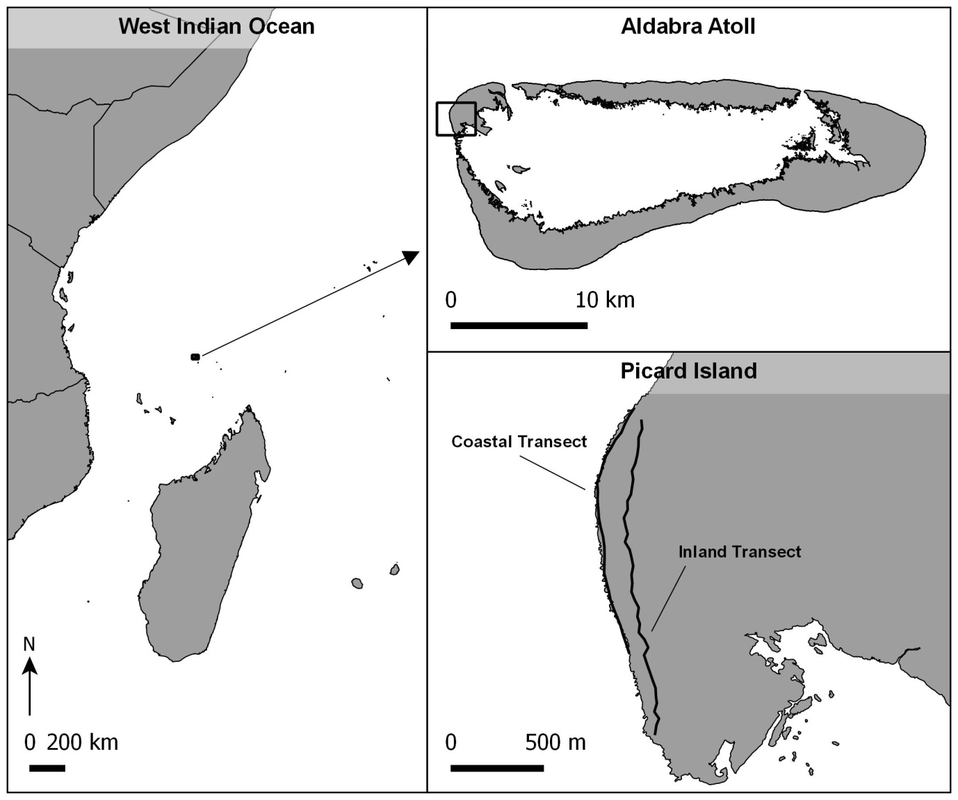**Figure 1.**

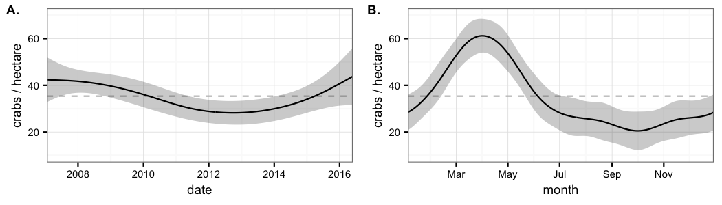**Figure 2.**

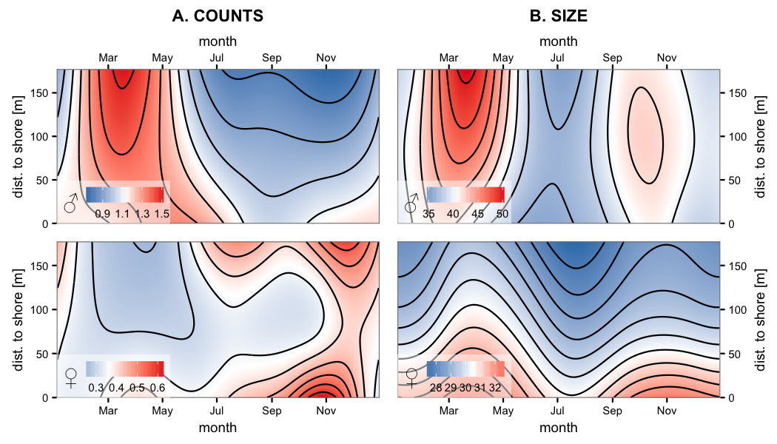**Figure 3.**

**Figure 4.**

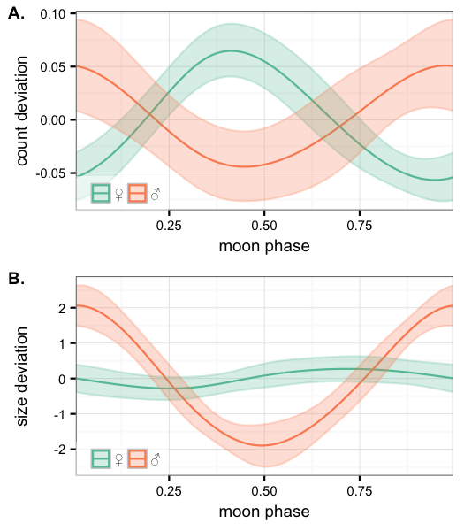

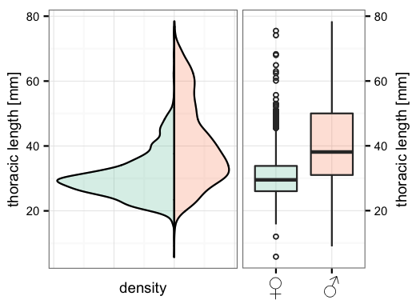**Figure 5.**

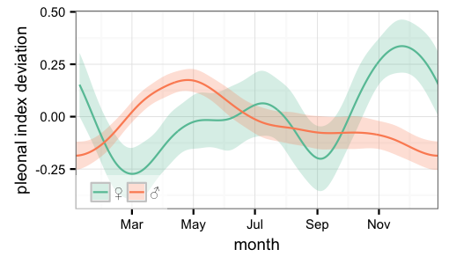**Figure 6.**

**Figure 7.**

